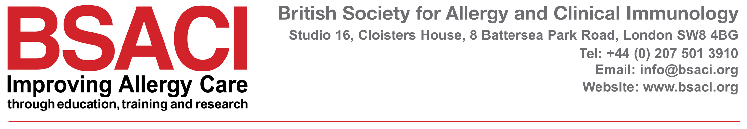

Resolving Complaints in Relation to Work of BSACI Committees

- Preamble

- We are committed to providing a high-quality service for our members and to working in an open and accountable way that builds the trust and respect of all our stakeholders. One of the ways in which we can continue to improve is by listening and responding to the views of our members and stakeholders.
This procedure has been developed to assist those who wish to make a complaint about the conduct of business within the society, specifically regarding an individual member of a committee and or Chair. It is intended to provide a framework to a fair, transparent, equitable and timely response to all complaints about the conduct of business.

Members who participate in BSACI roles do so because they share the same goals of improving allergy care for patients. Those involved often work long hours and in their own time. They are not financially rewarded for their valuable contribution. The society Trustees value and recognise the contributions and commitment which is undertaken by BSACI members by providing a safe and supportive environment in which to carry out the work of the society as well as to offer support via its staff at the BSACI Office.

- Members or stakeholders should be encouraged to address the conduct of another, if they felt this was inappropriate.

- Trustees would expect that minor queries about the way business is conducted should be resolved informally, in the first instance, by open and direct communication with the person(s) with whom the query/conduct relates to.

- However, we recognise that resolution at this stage may not always be possible and where this is not, this policy will assist in the situation where additional assistance is needed in order to achieve a resolution.

- MAKING A COMPLAINT

- In the first instance, the complaint should be raised informally with the Chair of the committee concerned. If the complaint is about the Chair then you are required to write to the Honorary Officers of the Society via the Chief Executive. If the conduct is about the Chief Executive it should be addressed directly to the President.

- Formal complaints should be made in writing, either by letter or email, and should identify;

  - The nature of the complaint
  - Who has been involved
  - What has/ has not been done
  - Why you are not satisfied with the outcome
  - How you would like to see the matter resolved

- STAGE ONE

- The complaint will be acknowledged by the Chief Executive (or President in circumstances outlined in point 5) and will be discussed with the Honorary Officers within one week of receipt of complaint. The complainant will be advised that the process will entail making a copy of the complaint available to the Chair of the Committee/Group concerned so they have an opportunity to review the complaint accordingly. NB: If the complaint is about one of the Honorary Officers, or the President the two other Officers will be asked to assist.

- The nature of the initial discussion is to assess:
  - If the nature of the complaint can be resolved easily by a series of conversations
  - If not, which Honorary Officer (Lead Investigator) will be responsible for communicating directly with the complainant and relevant Chair of Committee.
  - Establish a timetable for discussions and decisions/resolution of the complaint.
  - Undertake to resolving actions as a result of the outcome of the complaint
  - Informing the committee in question of the situation (if this is deemed necessary)

STAGE 2

- The Lead Investigator will discuss this with both parties and staff (if relevant) within two weeks of receipt of the complaint, so as to be able to inform both parties of the next steps to be taken.

- The Lead investigator will arrange a discussion with the other members of the committee involved and obtain further facts from the BSACI staff member (if required), before making any decision.

- Should the Lead Investigator consider it necessary, the details will be discussed with one other trustee.

STAGE 3

- The Lead Investigator may decide (having gone through the evidence ) that a resolution could be achieved by facilitating a meeting of both parties. If this is the case a meeting will be held within two weeks of the decision being conveyed to both parties.

- Any decision on how to proceed should be conveyed to both parties within two working days of the decision being taken.

- It is hoped that the proposed way forward would be acceptable to both parties. Should this not be the case either party has the right to request an overview of the details by HR Dept Clapham, (Link) who may speak to both parties and the Lead Investigator. The HR Dept Clapham will then be asked to make a decision based on the information provided no longer than two weeks after being asked to do so.

- The final decision will be conveyed to both parties no later than 3 weeks after an appeal has been lodged.

- It is expected that all parties will accept the proposed resolution of the complaint.

No more than four weeks after the complaint has been resolved the Trustees will review the complaint and the procedures used in the resolution process and take steps to avoid a similar complaint happening in future, so as to improve the overall way in which the society operates.
This policy has been informed by the ‘The British Thoracic Society (BTS)’ ‘Dealing with complaints and/or concerns about the work of a BTS committee or Group’.

Approved at the 2020 BSACI AGM
Updated Sept 2021

