Proposed Rule Change

BSACI are proposing the following amendment to the current rules of the society, which we feel best reflects the current climate in which the society operates. At present there are no specific details in the rules stating who can vote on council. We would therefore like to invite members to review the proposed additional text in red below, so it can be ratified at the 2021 AGM.

AGM are asked to ratify the following addition to the Rule 21. The additional wording is highlighted in red below;

BSACI Council shall consist of the Officers, the Editor(s) of the Society's Journal, chairs of the sub-committees of Council, immediate past President, the President-Elect, the Deputy Meetings Secretary and seven elected Members ("Members of the Council"). Members of the Council shall be elected for a period of three years and shall not be eligible for immediate re-election as a Member of Council after their term of office is completed. NB: Elected council members are the only members on council eligible to vote.

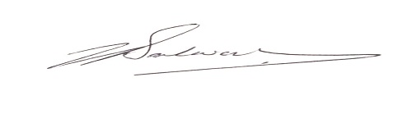

Dr Nicola Brathwaite
BSACI Secretary

