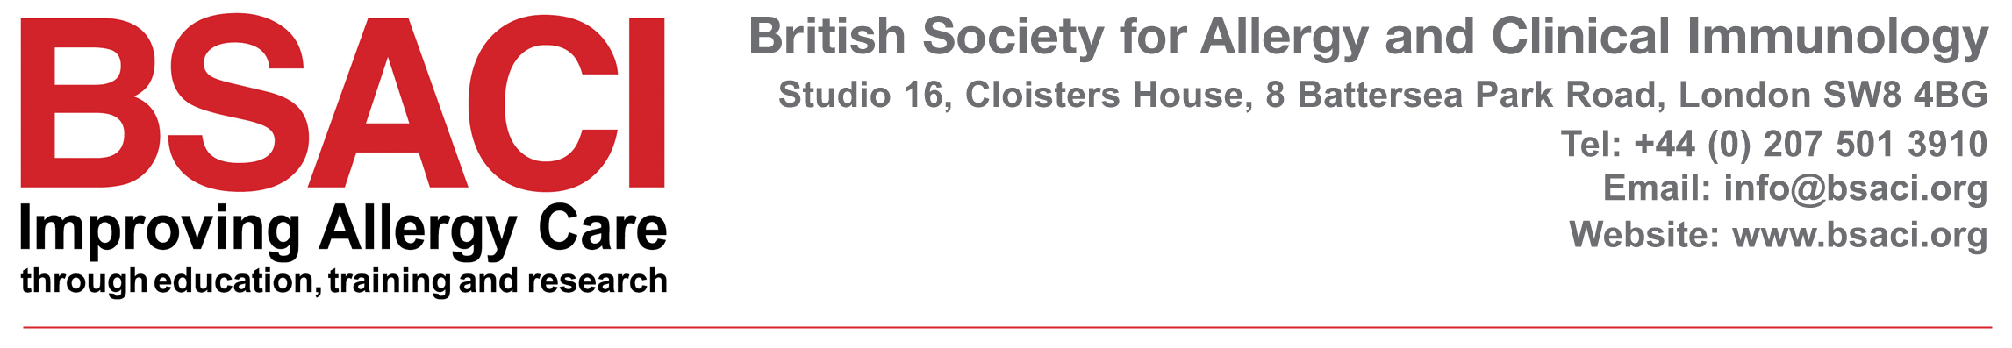

Company Number: 3505635

THE COMPANIES ACT 1985

NOTICE CONVENING ANNUAL GENERAL MEETING of the
BRITISH SOCIETY FOR ALLERGY & CLINICAL IMMUNOLOGY

NOTICE IS HEREBY GIVEN that the 2022 Annual General Meeting of the company will be held on Zoom via meeting link on Monday 03 October 2022 at 5.00pm – 6.00pm to consider and, if thought fit, to pass the following resolutions of which resolutions 1 to 2 (inclusive) will be proposed as Ordinary Resolutions.

ORDINARY RESOLUTIONS

- To appoint the Auditors
- To transact any ordinary business of the company

BY ORDER OF THE BOARD

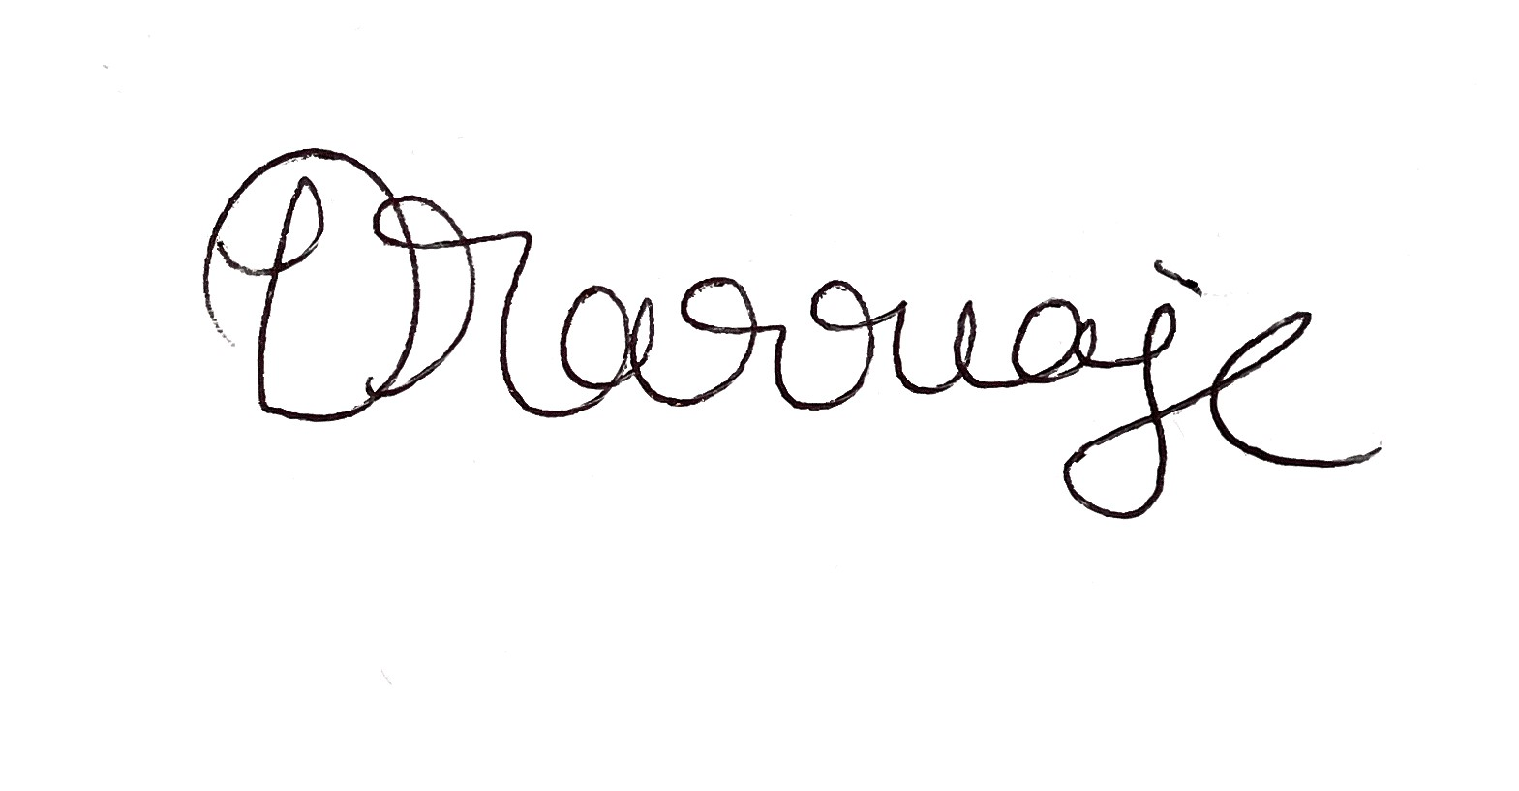

Dr Deb Marriage
Secretary

Dated: 14 June, 2022
Registered Office: Studio 16, Cloisters House, 8 Battersea Park Road, London SW8 4BG

Note: A member entitled to attend and vote at the above meeting is entitled to appoint a proxy to vote instead of themselves. A proxy need not be a member of the company.

